Group: K-3

Group Members: Daiyuan Ding

Ningyuan Zhang

Course: Cpr E 381

Section: K

Date: 9/28/2016

Group: K-3

TA: Taewoon Kim

Project Part A Report

1)

1. We need two data inputs, a carry-in input, a less input and a 3-bit oprands input as selector. We will have a result output, a set output and a carry-out output.

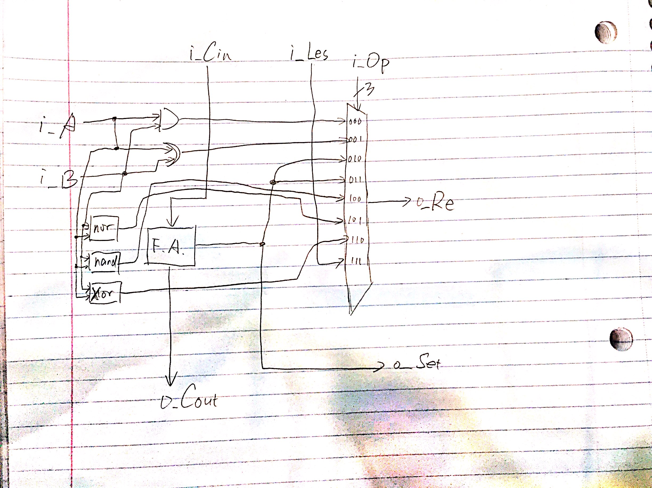

1. We used a mixed style which is mainly based on structual style. We created a B invert to choose whether if we need to invert data B to complete the sub and less than operation. Then we had 7 result signals to store results except less than. We also had a not B to store inverted data B and a B_ADDER to store the result of B after choosing not ot normal.
2. The results are shown as in the waveforms.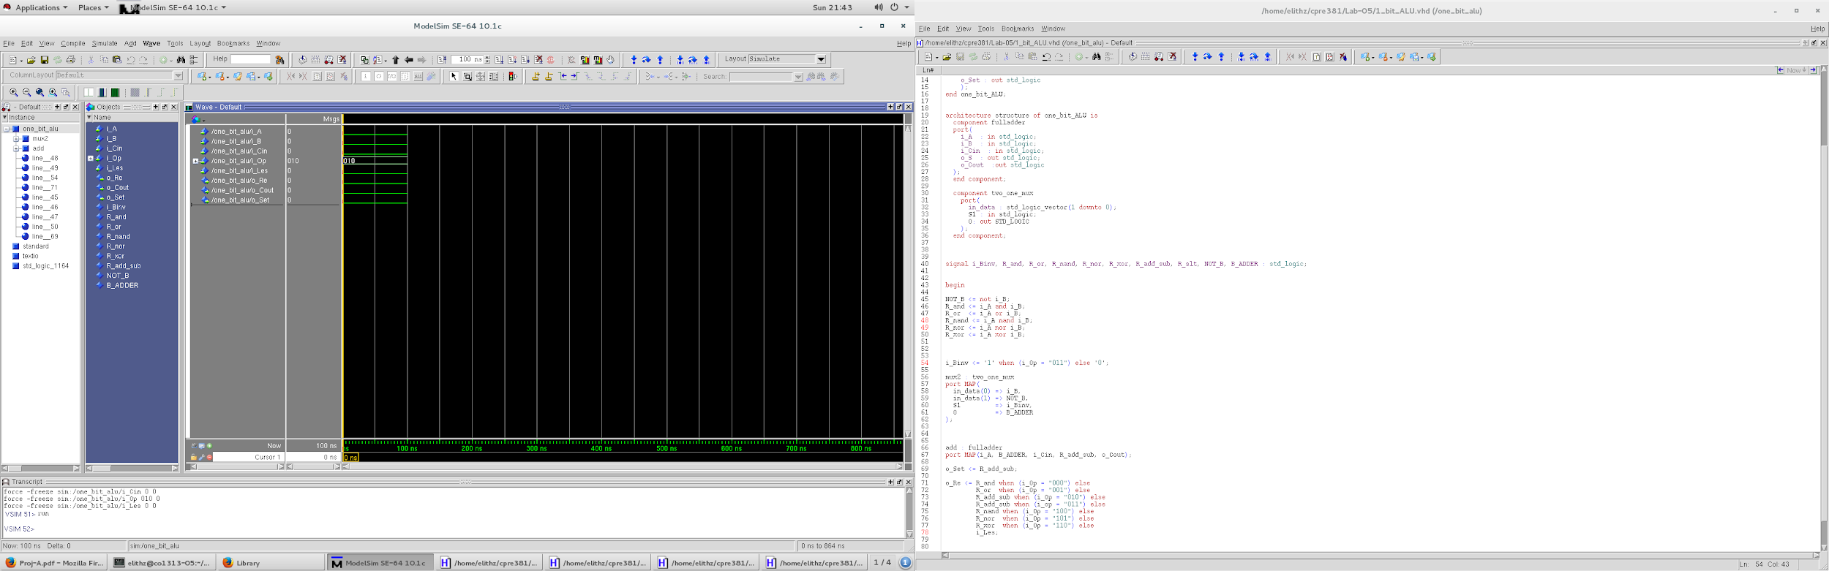

0 + 0

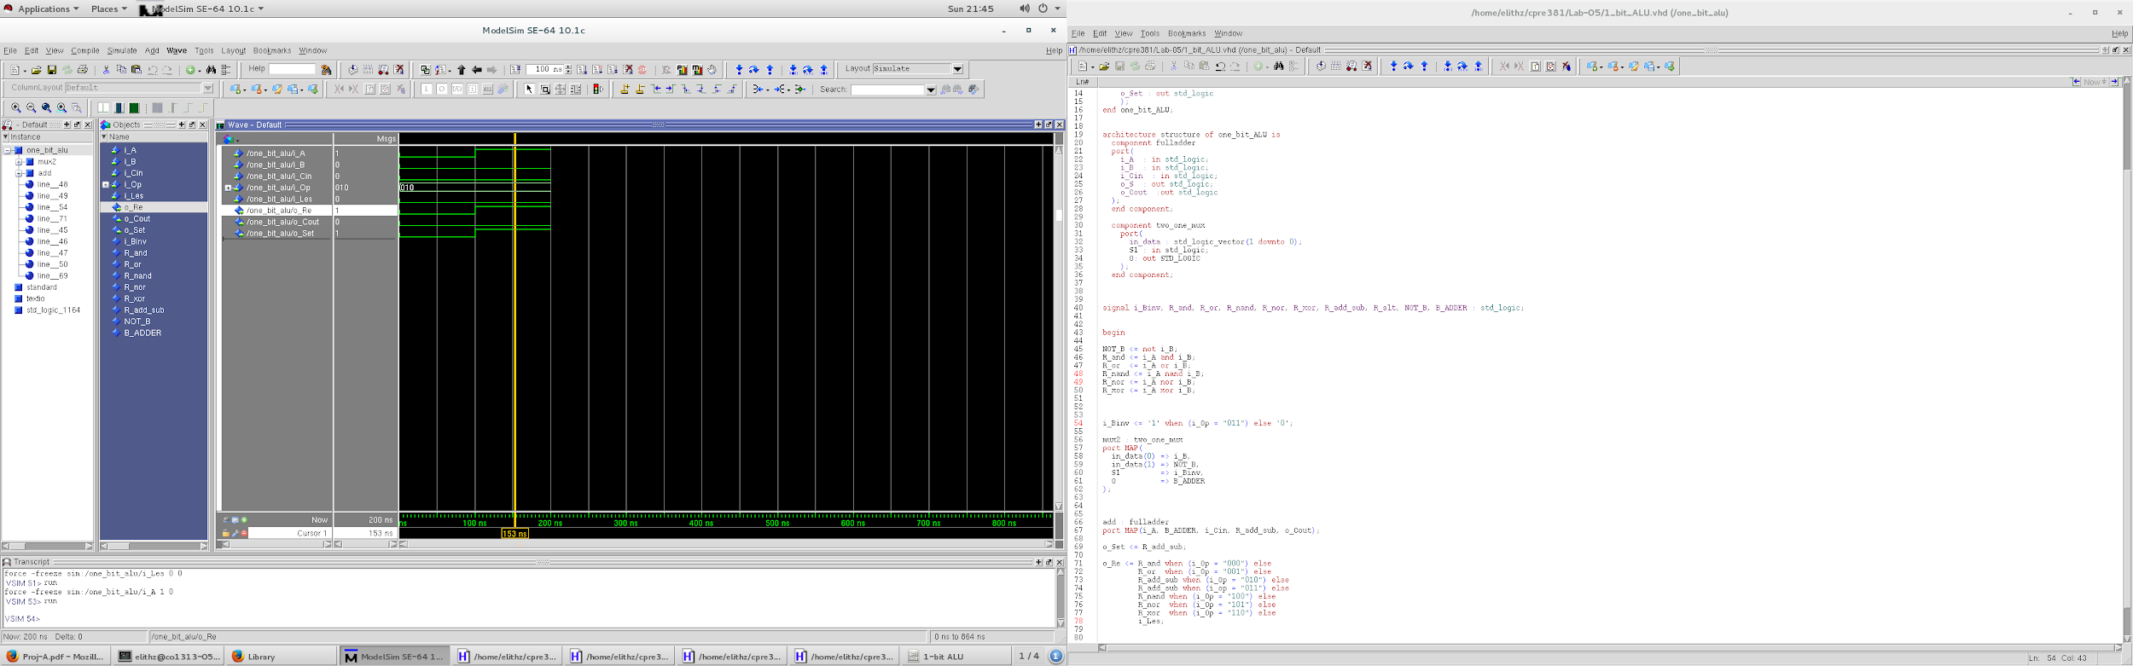

1 + 0 = 1

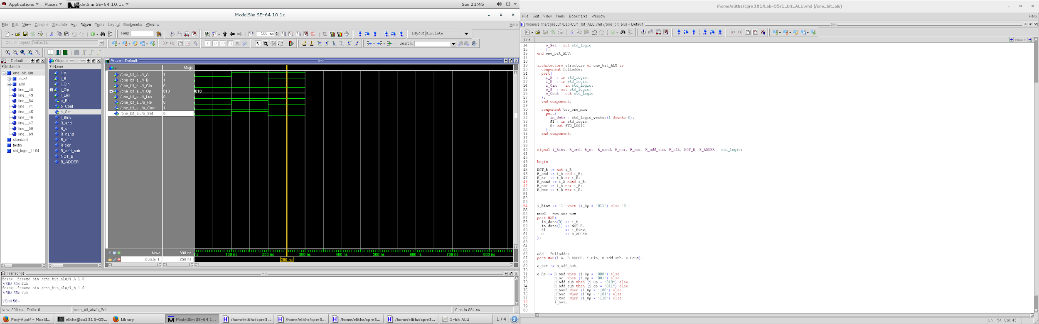

1 + 1 = (1)0 carry 1

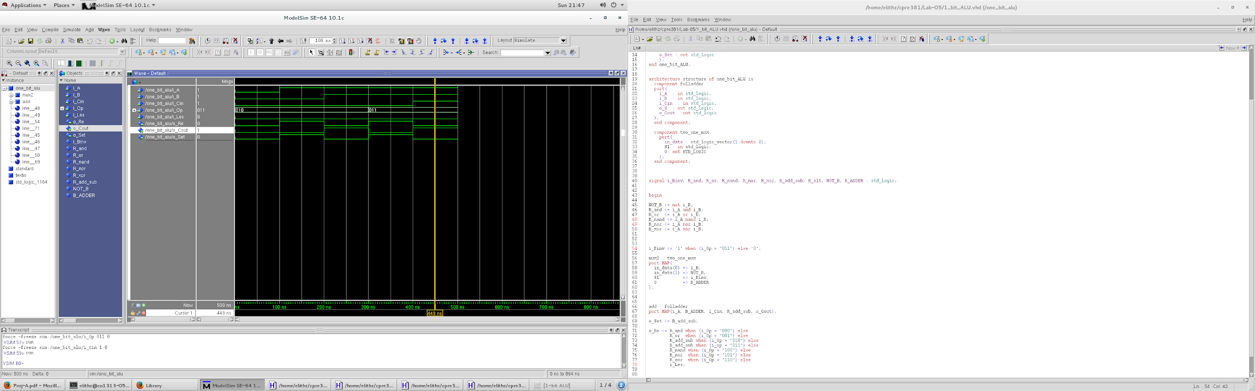

1 - 1 = 0 and set(slt) is 0 because they are equal

2)

1. overflow: when data are signed, overflow = A(31)B(31)S(31)’ + A(31)’B(31)’S(31); else it is the carryout of last adder.

Zero: when result is 0, it will be 1.

slt: is1 when A less than B, which means if is actually result(31) of sub op.

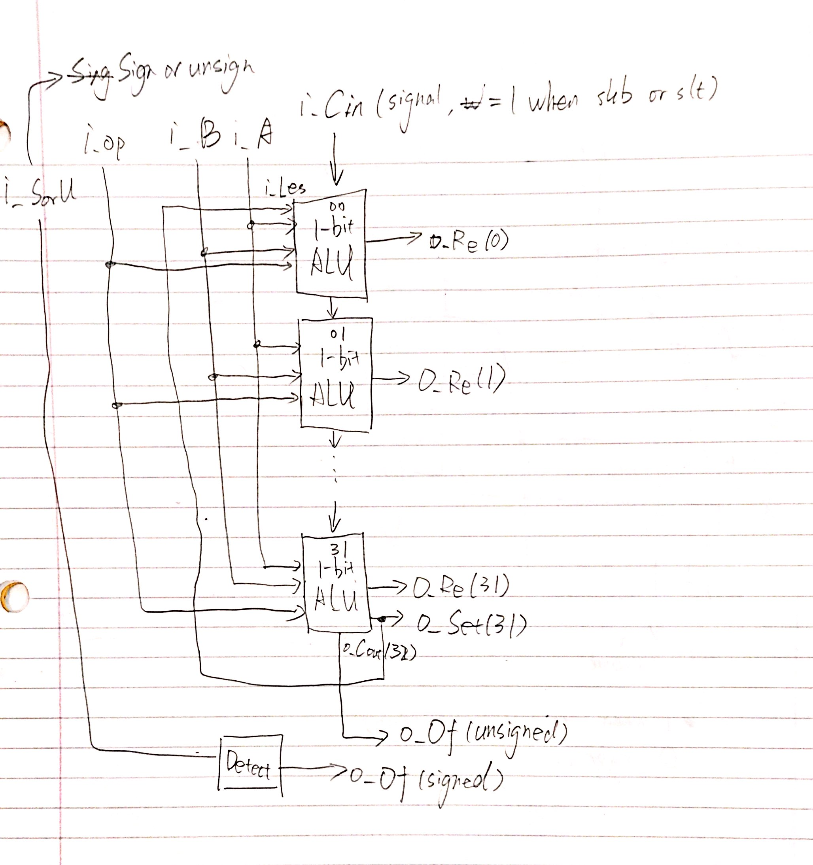

(b) loop, if statements and signals confused us, but we figured them out!

(c) the result is posted below:

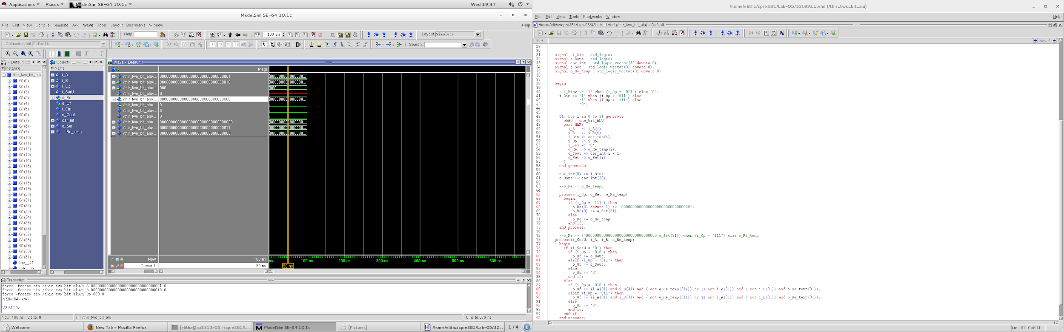

and

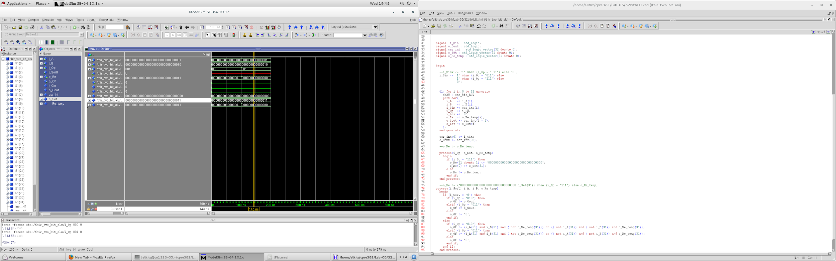

or

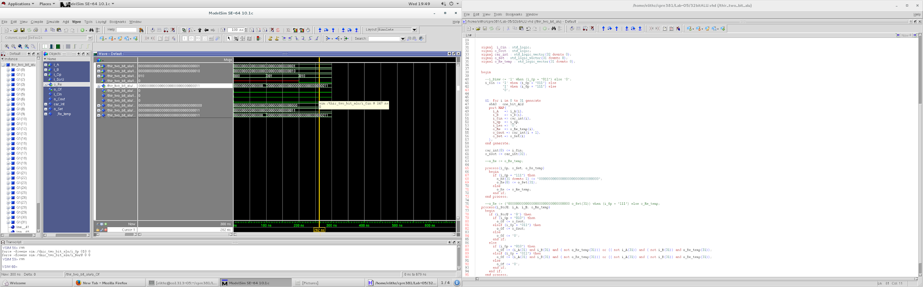

add

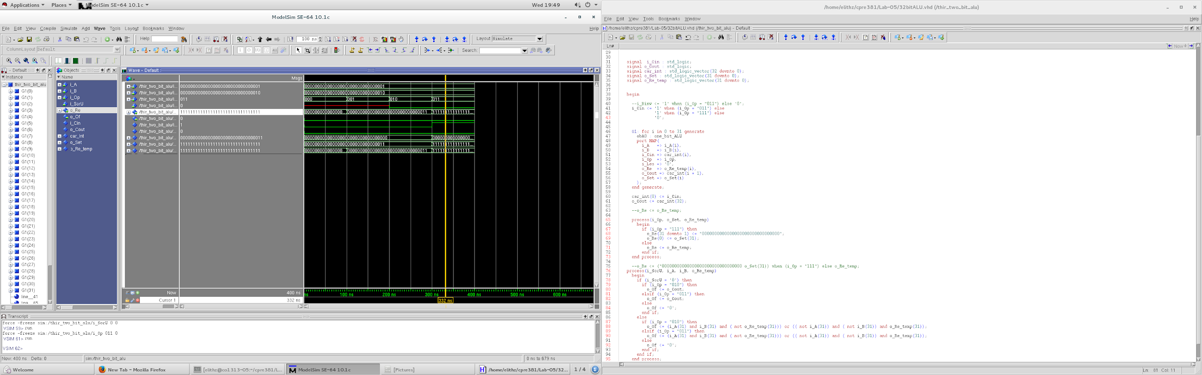

sub

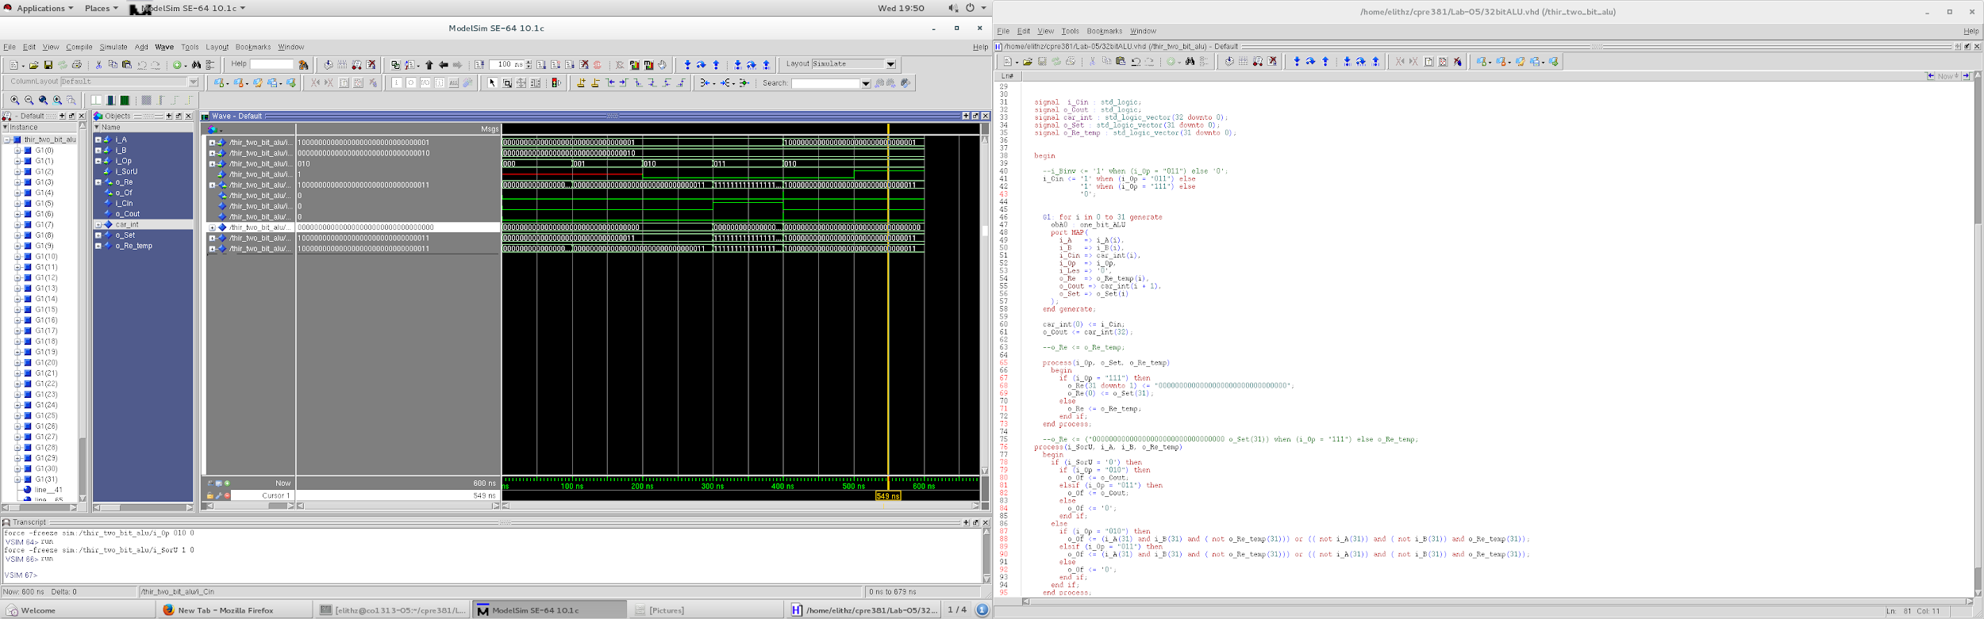

add unsigned

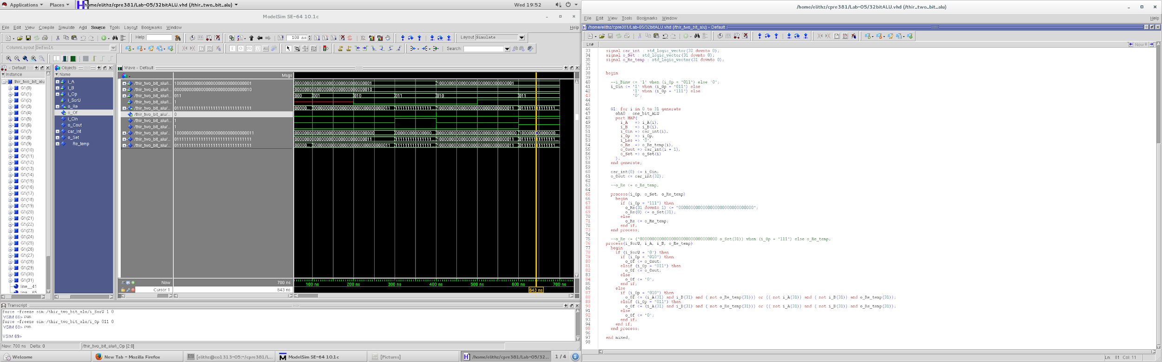

sub unsigned

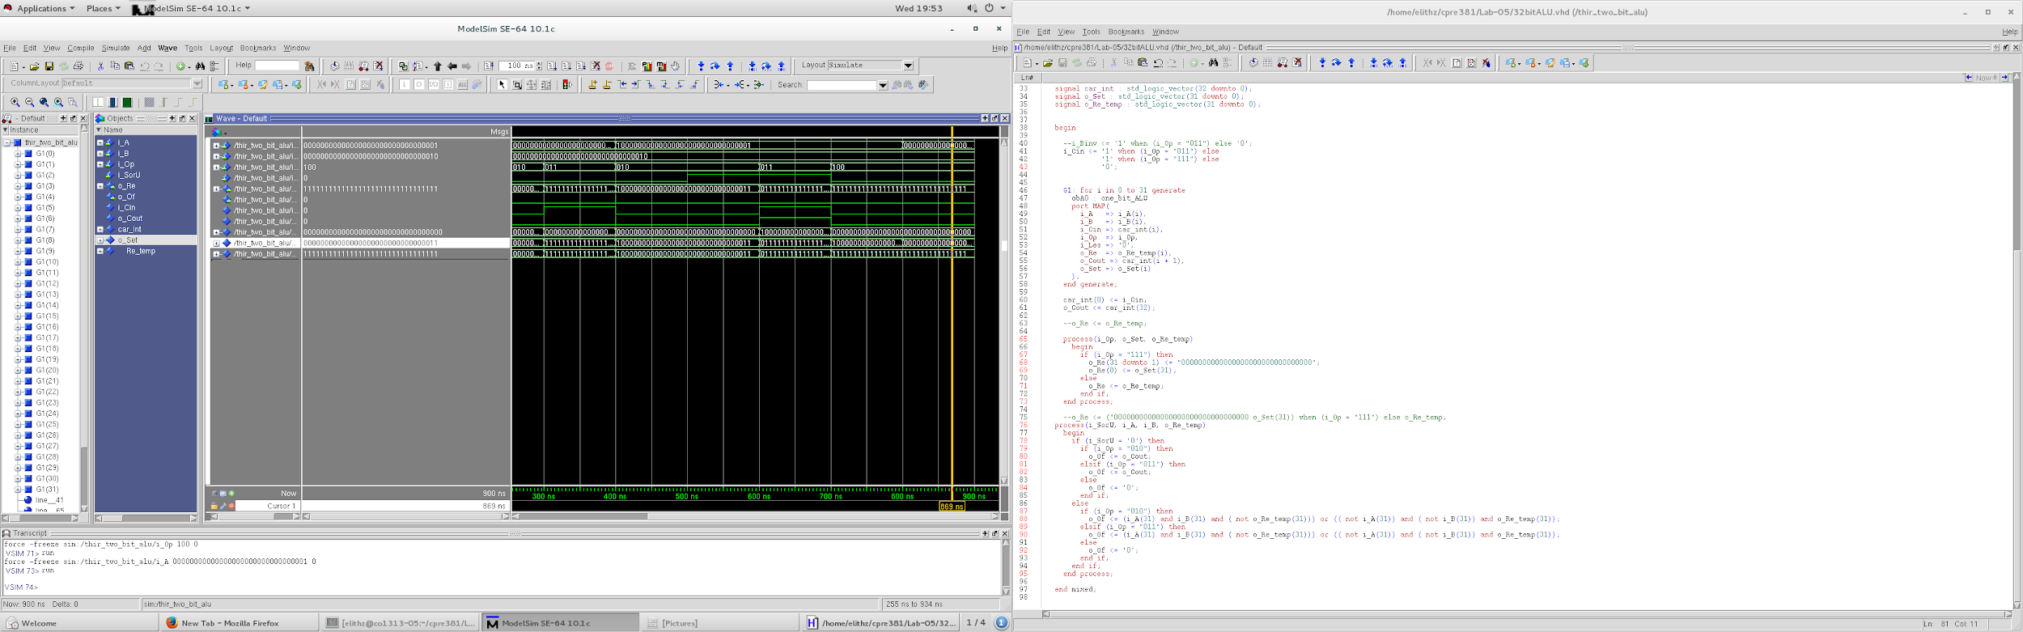

nand

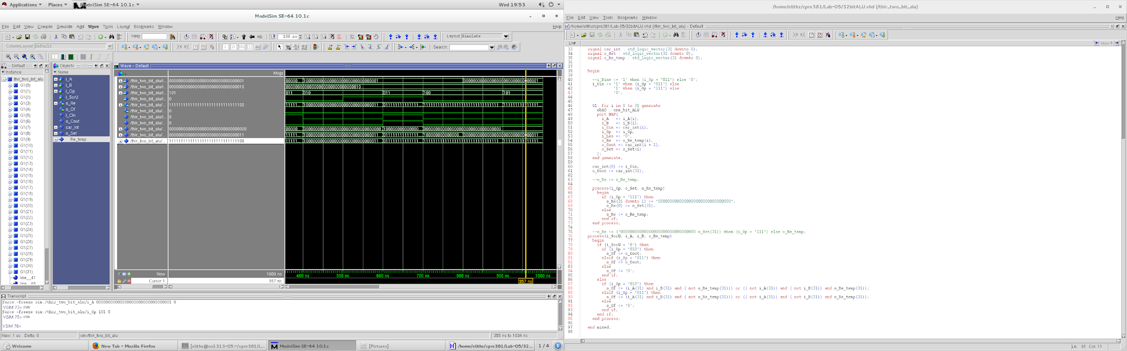

nor

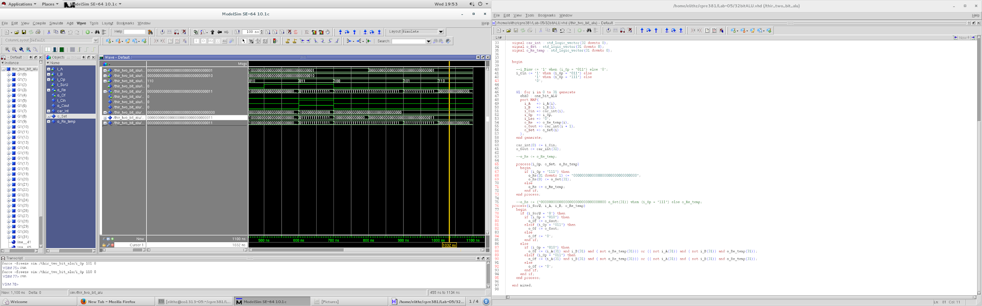

xor

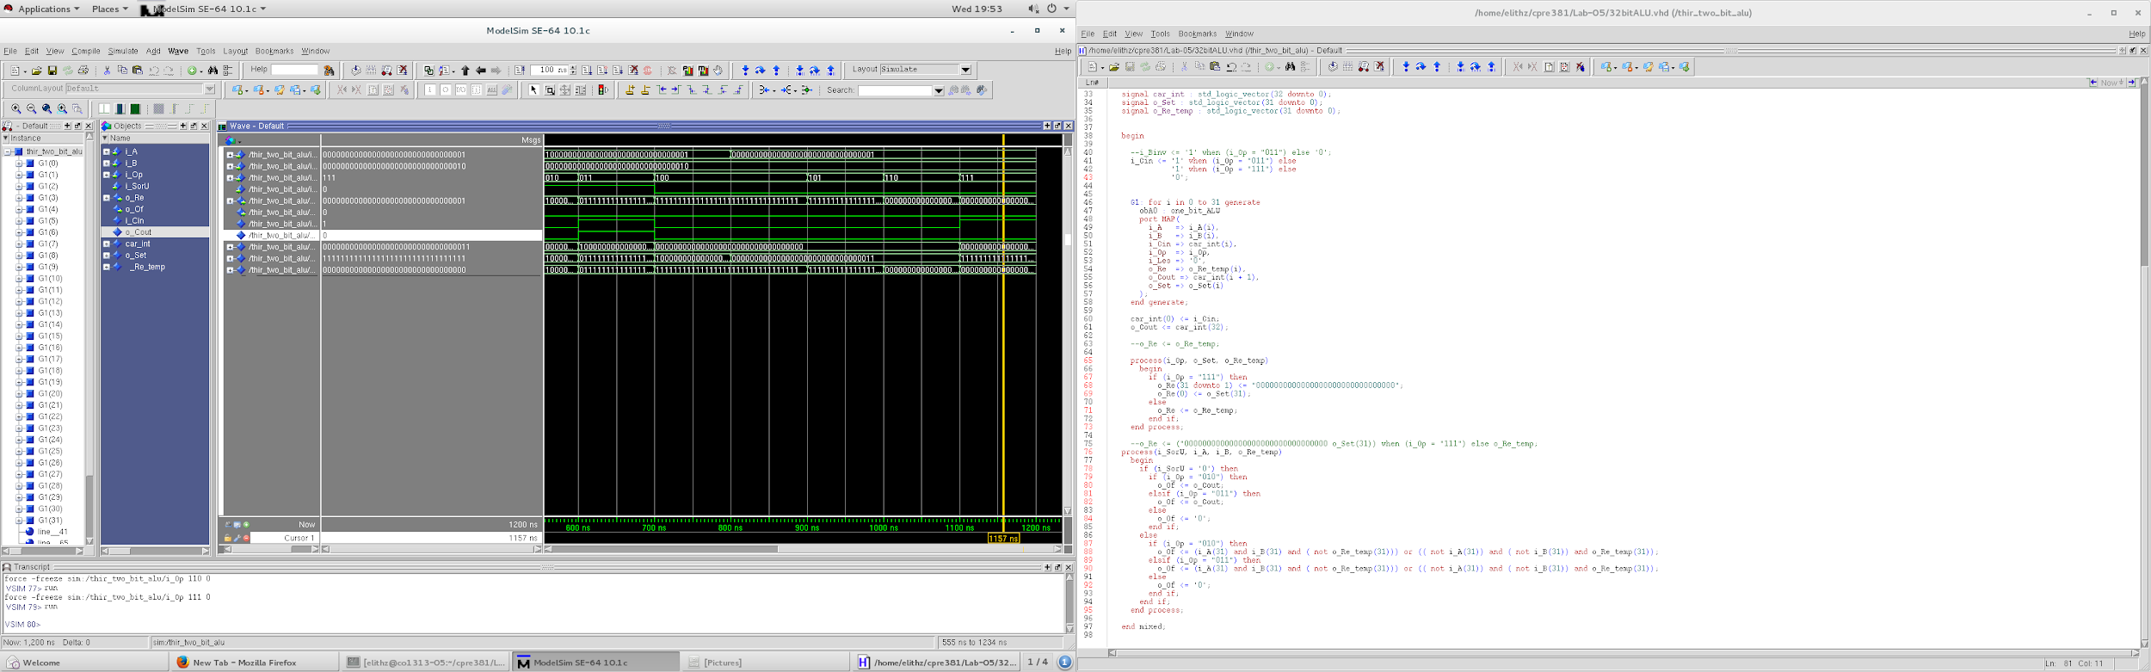

slt

3)

Fot the array multiplication, within two 32-bit inputs, the output should be 64-bit, but we only take the lower 32-bit. Generally, there are four differnet situations for multiplication operations, positive * positive, positive * negative, negative*positive, negative *negative. To solve these situations, we need two mutiplexer before import the data to the unsigned multiplicater. If the input number is negative, the mutiplexer would apply the two’s complement to the number. In addtion, the output of the mutiplicater also need apply a mutiplexer to determine the final output should be positive or negative. If the two intial inputs are both positive or negative, then it don’t need apply the two’s complement. Otherwise, it need apply the two’s complement.

For the testbench, we apply four different situations. First is 42 * 10, Second is 42* -10, Third is -42 * 10, Fourth is -42 * -10. It covers all the four situations the signed multiplication would face. The screenshots is below.

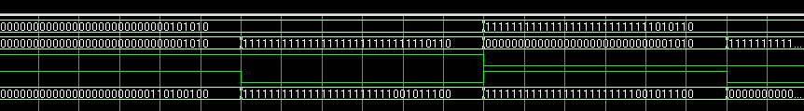

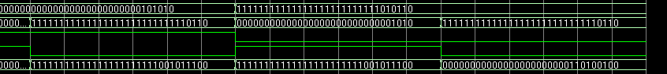

4)

1. srl is shift right logic, which means it dose not care about the signs, but sra, which stands for shift right arithmetic, requires the data that needs to be shifted to be a signed number, and it will fill 1 when data is negative and 0 when the data is positive. Because when we shift left, it will fill right hand which will always be 0 instead of signs.
2. We first implemented a function to convert the number that we need to shift from binary to dicimal, and then we used several if statements to make sure which type of shift it was operating. Then we tried to and their bits to get the correct results.
3. For this part, we just swaped the bits that need to be anded.
4. picture was shown below

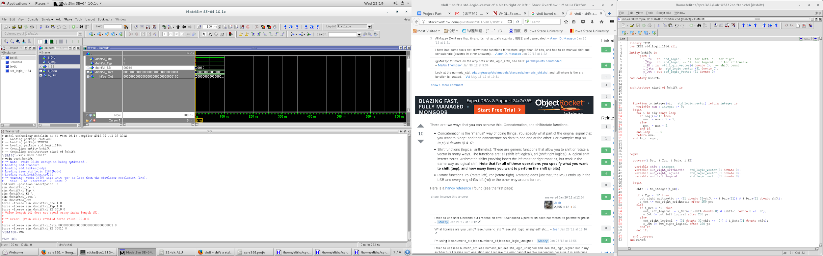

sll 2 bit

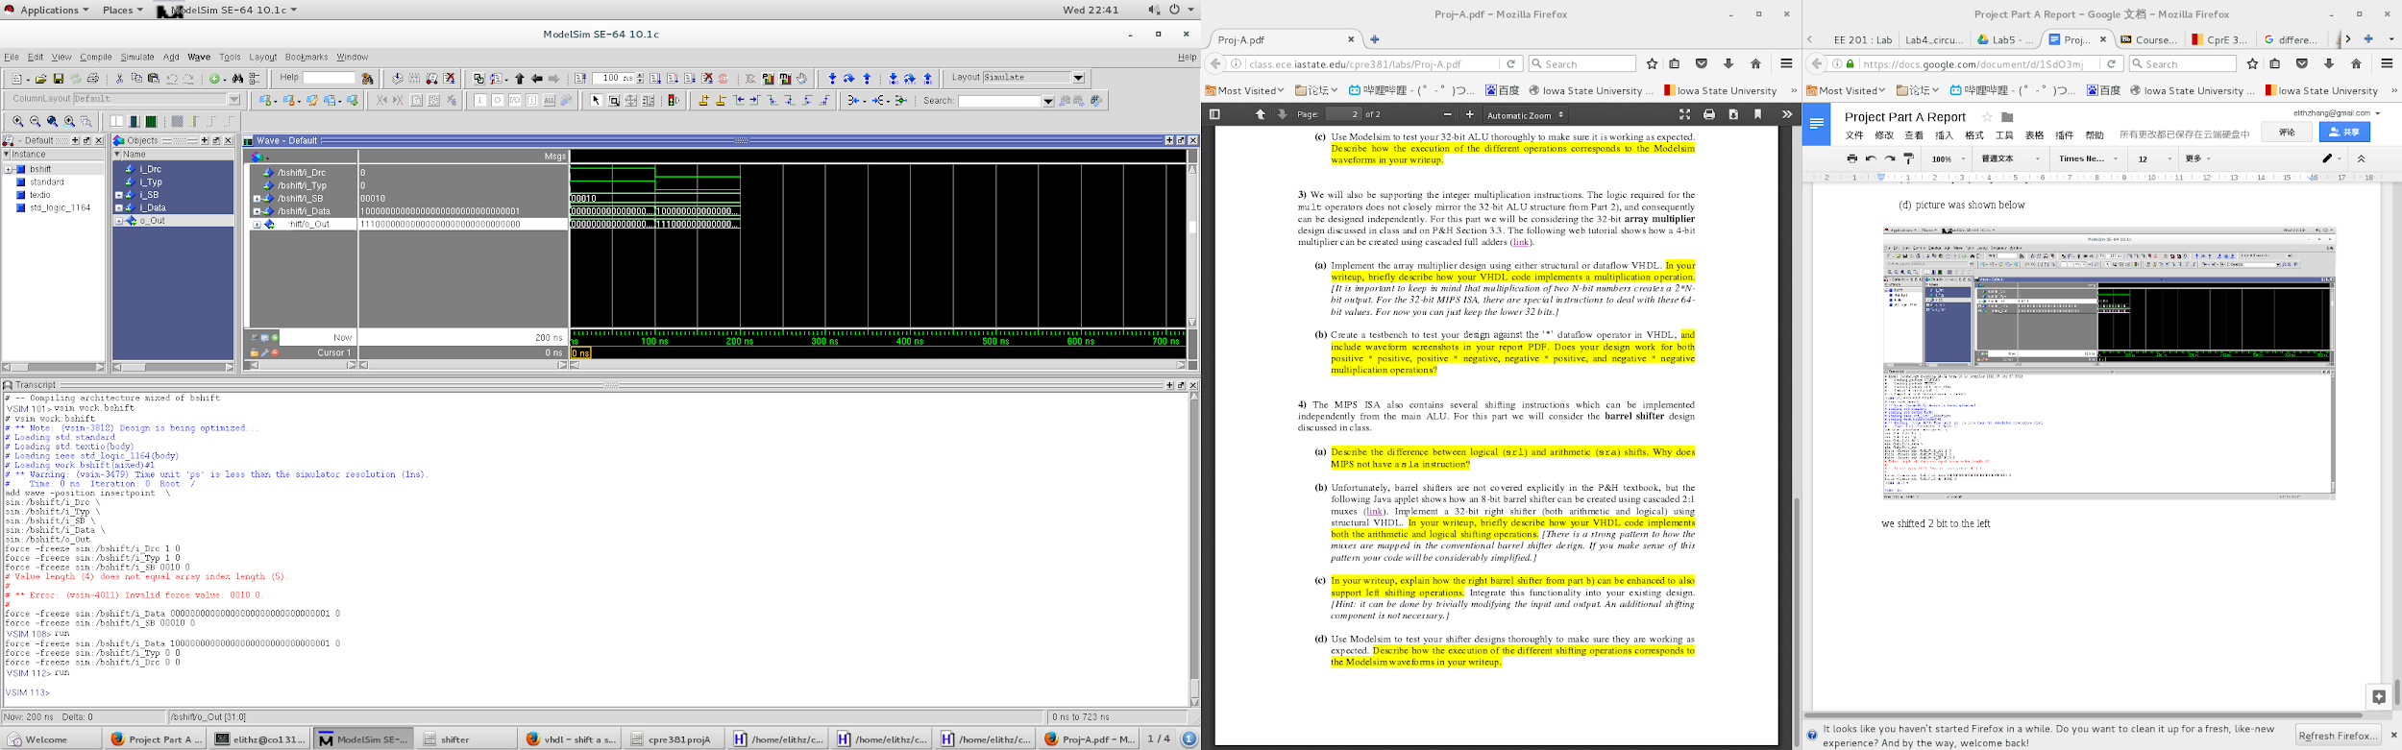

sra 2 bit

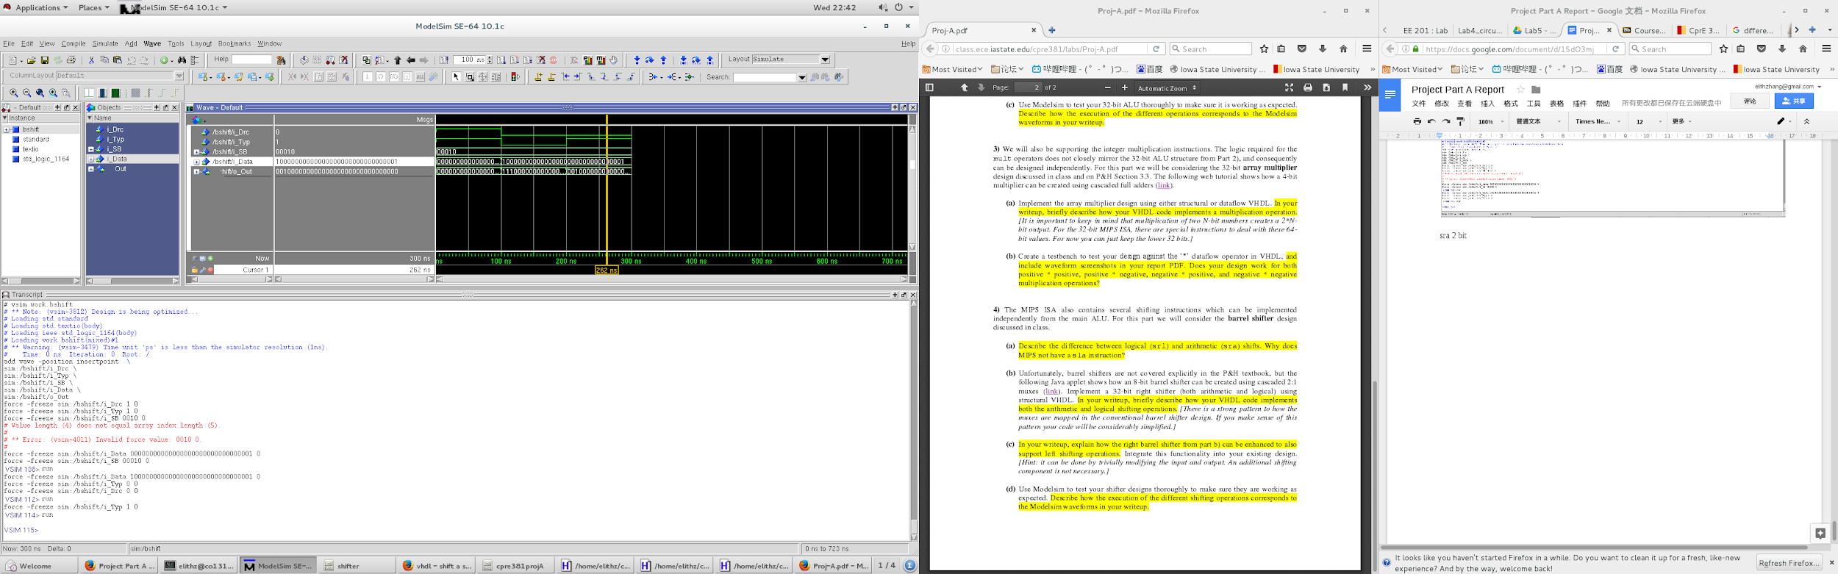

srl 2 bit